DEAFBLIND CAMP OF
MARYLAND
JUNE 11TH, 2023
TO
JUNE 16TH, 2023

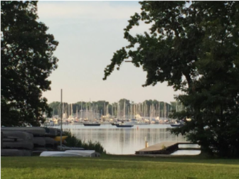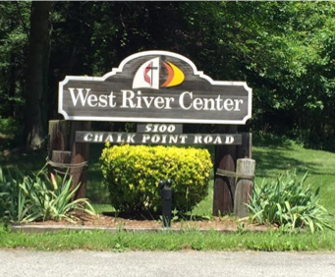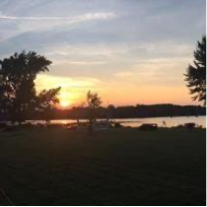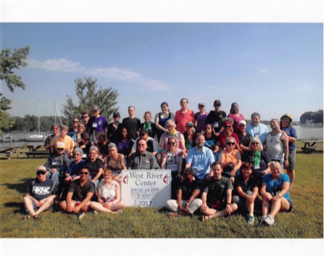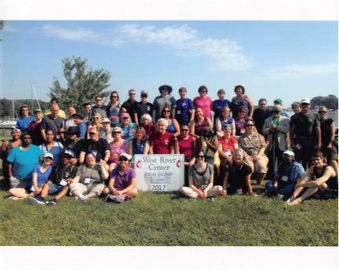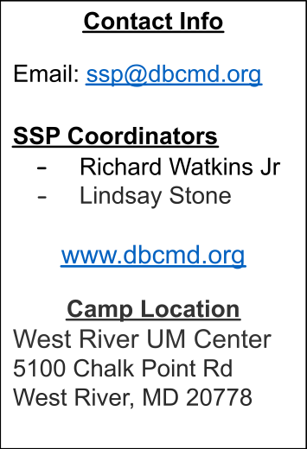Heading 1
Heading 4

Come and Join us at DeafBlind Camp of Maryland this June in beautiful West River, Maryland! During the week you will be able to immerse
yourself into the DeafBlind community; providing accessibility for individuals with varying levels of vision and hearing loss using various communication
methods such as ASL, Tactile ASL, Spoken Language, and more. Human guiding techniques as well!

https://forms.gle/2JxC7xTKxxj13B1x7

